**Cross Zone load balancing:**

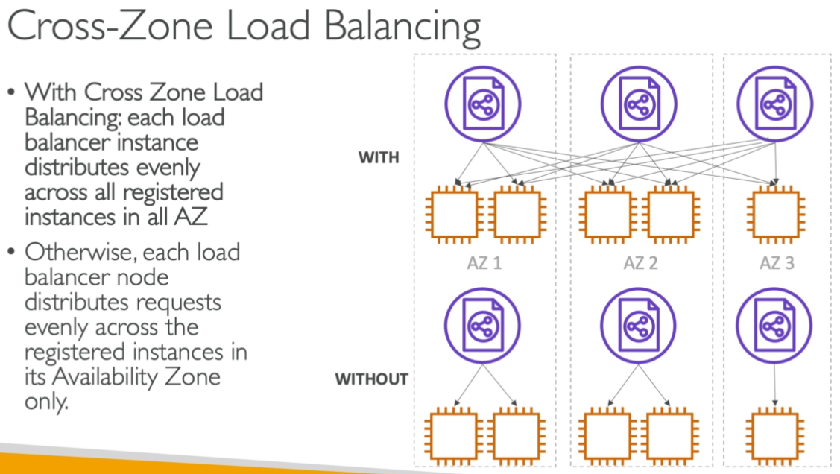

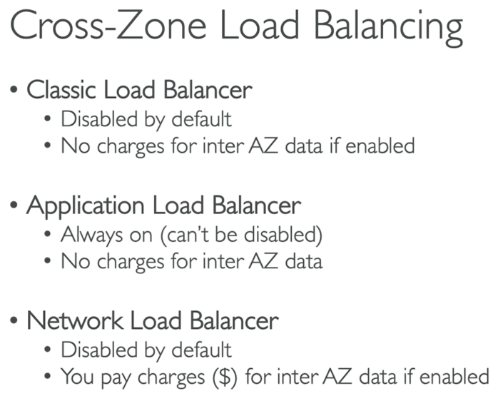

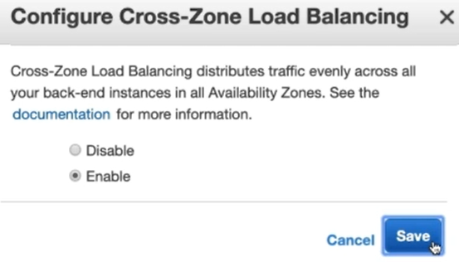

* We can just enable it in classic load balancer as it is disabled by default.

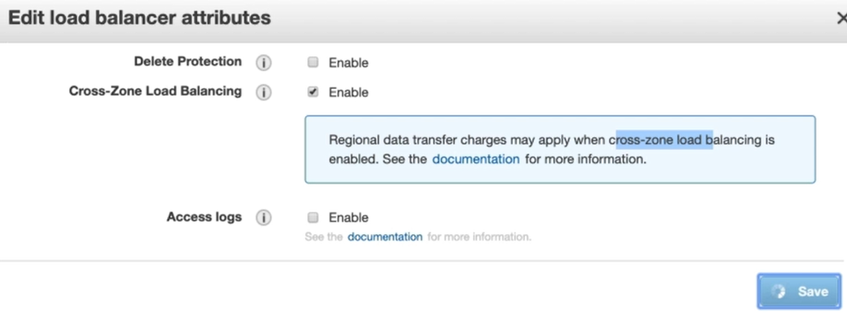

* But the same will be charged if we enable in NLB.
* If we enable the cross-zone load balancing, it sends the traffic to all zones equally
* If we don’t enable it. It sends half traffic to one zone and half to another. If zone1 has 10 servers, it sends 50% traffic to zone1 and if zone2 has 20 servers, then also it sends only 50% traffic means there will be high load on zone1